Table of Contents

Task Setup 1

Task Token Service 1

Task Smart Contract Service 2

Task Scheduled Transaction 2

Task Multisignature 2

Task Consensus 2

# Task Setup

Logs -

Hedera_certification/01_Task_Setup/logs

Account Details can be found in below file -

Hedera_certification/accountDetails.json

Account1 is attached below -

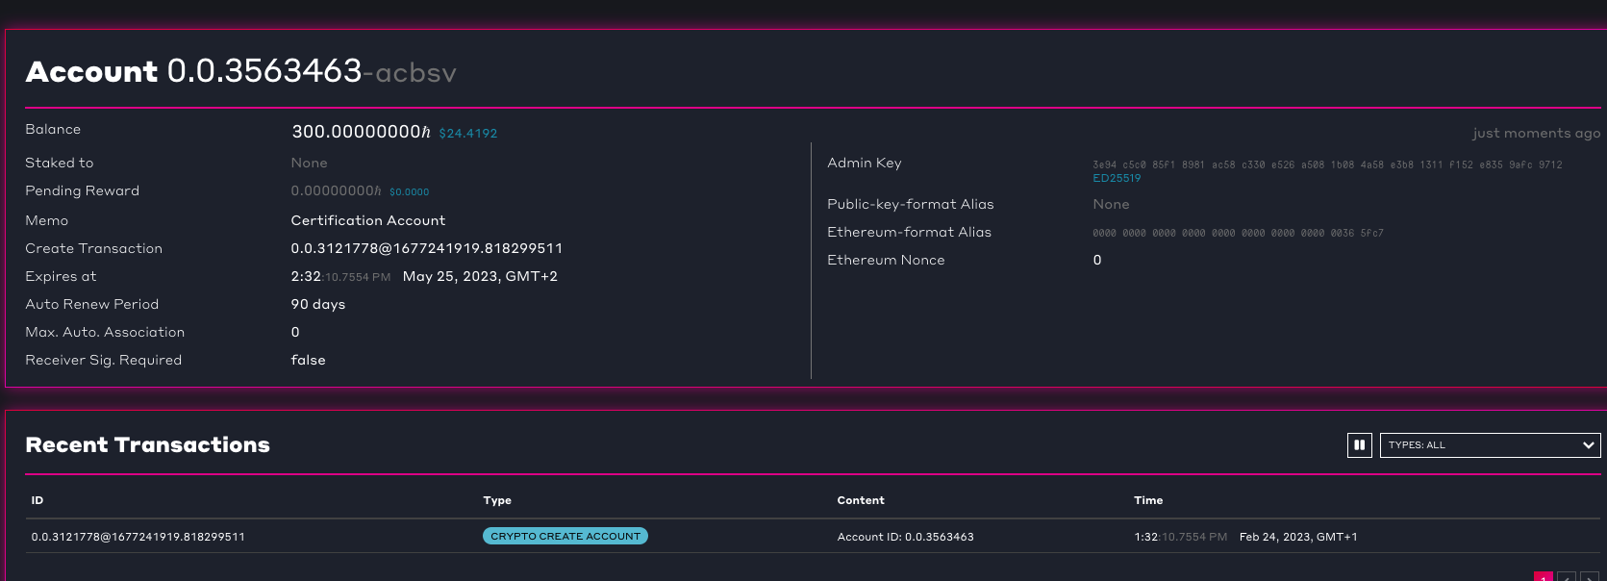

# Task Token Service

Hedera_certification/02_Task_Token_Service/logs

Create token -

Token Transfer –

Pause Token

Success transfer after unpause

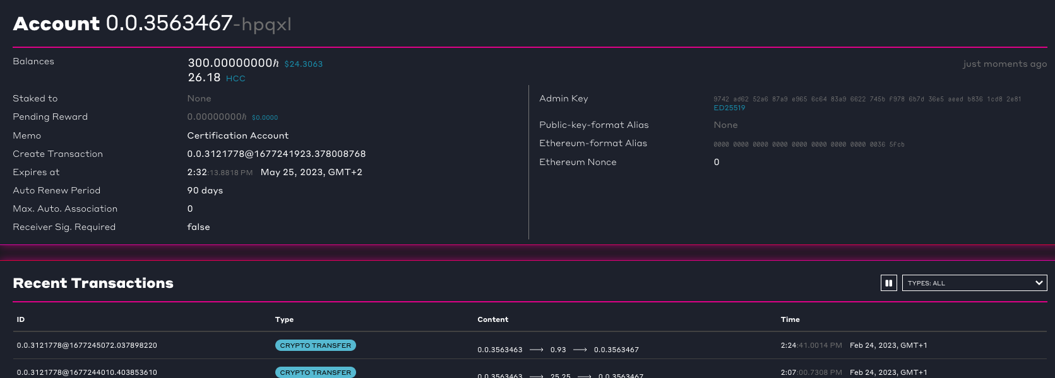

# Task Smart Contract Service

Result can be found on log -

Hedera_certification/03_SmartContract_Service/logs

Deployed Contract -

# Task Scheduled Transaction

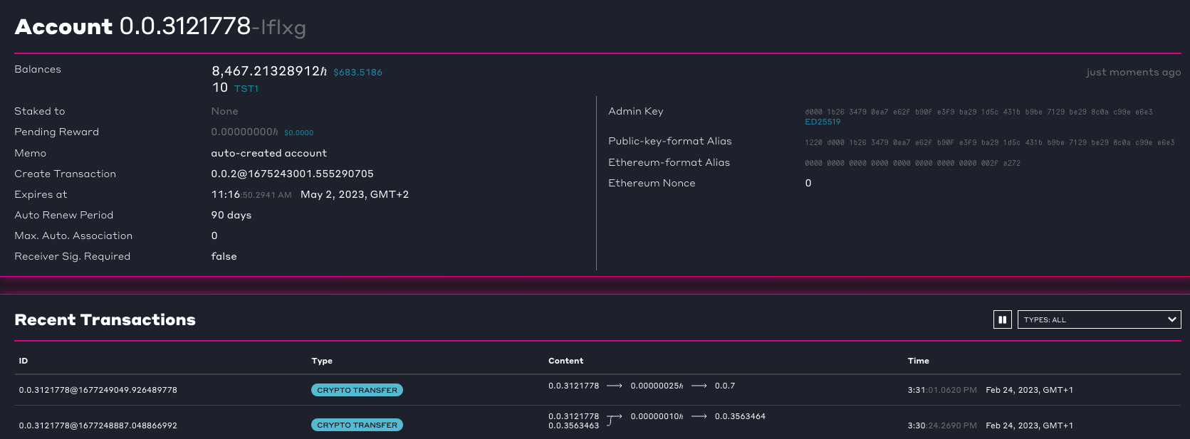

# Task Multisignature

# Task Consensus

